Problem#1
public class BankAccount {  String name;  String id;  double balance;  public BankAccount(String name, String id, double balance){  this.name = name;  this.id = id;  this.balance = balance;  }  public void deposit(double depAmount){  if(depAmount > 0){  balance += depAmount;  System.out.println("Deposited: " +depAmount);  }  }  public void withdraw (double withAmount){  if(withAmount > 0 && withAmount <= balance){  balance -= withAmount;  System.out.println("Withdrawn: " +withAmount);  }else{  System.out.println("Insufficient balance!");  }  }  public double getBalance(){  return balance;  }  public void displayInfo(){  System.out.println("Name: " + name + "; Id: " + id + "; Balance: " + balance);  }  } | public class Bank {  public static void main(String[] args){  BankAccount account = new BankAccount("Saad", "24201212",10000);  account.withdraw(200);  account.displayInfo();  account.deposit(500);  System.out.println("Current Balance: " +account.getBalance());  }  }

Input | Output
 | 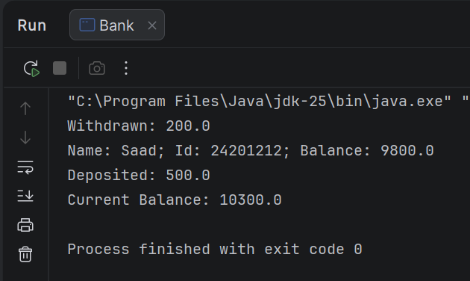

Problem#2
import java.sql.Struct;  public class Student {  String name;  String id;  String enrolledCourse;  public Student(){  }  public Student(String name,String id){  this.name = name;  this.id = id;  }  public void enrolledCourse(String enrolledCourse){  this.enrolledCourse = enrolledCourse;  }  public void displayInfo(){  System.out.println("Your name is " +name);  System.out.println("Your Enrolled course " +enrolledCourse);  System.out.println("your id " +id);  }  } | public class UapCse {  public static void main(String[] args){  Student std1 = new Student("saad","24201212");  std1.enrolledCourse("CSE");  std1.displayInfo();  }  }

Input | Output
 | 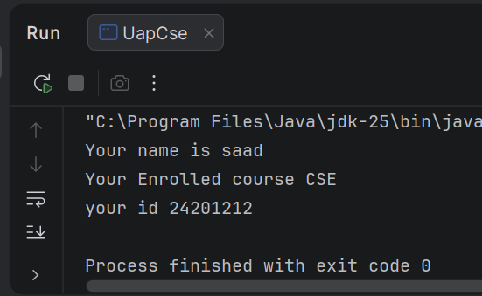

Problem#3
public class Product {  String name;  int id;  double price;  double discountPercentage;  public Product(String name, int id, double price, double discountPercentage) {  this.name = name;  this.id = id;  this.price = price;  this.discountPercentage = discountPercentage;  }  public void updatePrice(double newPrice) {  price = newPrice;  }  public double getPrice() {  return price;  }  public void setDiscountPercentage(double discPercentage) {  discountPercentage = discPercentage;  }  public double getDiscountedPrice() {  return price - (price * discountPercentage / 100);  }  public void displayInfo() {  System.out.println("Product Name: " +name);  System.out.println("Product ID: " +id);  System.out.println("Price: " +price);  System.out.println("Discount: " +discountPercentage + "%");  }  } | public class UapBazar {  public static void main(String[] args) {  Product product = new Product("dontknow", 212, 9999, 0);  System.out.println("Current Price: " +product.getPrice());  product.updatePrice(255);  product.displayInfo();  product.setDiscountPercentage(20);  double discountedPrice = product.getDiscountedPrice();  System.out.println("Discounted Price: " +discountedPrice);  }  }

Input | Output
 | 